Introduction to Swing:
Swing:
Java Swing is a part of Java Foundation Classes (JFC) that is used to create window-based applications. It is built on the top of AWT (Abstract Windowing Toolkit) API and entirely written in java.
Unlike AWT, Java Swing provides platform-independent and lightweight components.
The javax.swing package provides classes for java swing API such as JButton, JTextField, JTextArea, JRadioButton, JCheckbox, JMenu, JColorChooser etc.
What is JFC
The Java Foundation Classes (JFC) are a set of GUI components which simplify the development of desktop applications.

Hierarchy of Java Swing classes
The hierarchy of java swing API is given below.
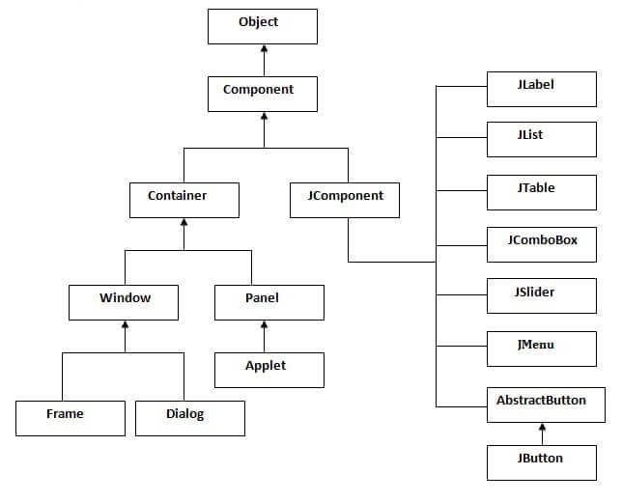

Object
- At the top of the hierarchy is the Object class.
- Since every class in Java inherits from Object, all GUI components are indirectly its subclasses.

Component
- Component is the superclass for all AWT and Swing graphical components.
- It provides basic features like size, position, colors, and event handling.

Container
- A Container is a special type of Component that can hold and organize other components.
- It acts like a "box" where buttons, labels, or other components can be placed.

Types of Containers
- Window
  - A top-level container that represents a standalone window.
  - Two main subclasses:
    - Frame → A main window with a title bar and buttons (minimize, maximize, close).
    - Dialog → A pop-up window (like a message box or confirmation dialog).
- Panel
  - A simple container used to group components together inside a window.
  - Applet → A type of Panel used to create small programs embedded in browsers (older Java technology).

JComponent
- JComponent is the base class for all Swing components (the modern Java GUI toolkit).
- It extends Container, meaning it can also hold other components.
- Provides additional features like pluggable look-and-feel, borders, tooltips, etc.
- JLabel → Displays text or images.
- JList → Displays a list of items.
- JTable → Displays tabular (row/column) data.
- JComboBox → A dropdown list.
- JSlider → A slider control to select a value from a range.
- JMenu → Represents a menu (used in menu bars).
- AbstractButton (Superclass for button types)
  - JButton → A push button.
  - (Other button types like JCheckBox, JRadioButton also come from this.)

Java Swing Examples
There are two ways to create a frame:
- By creating the object of Frame class (association)
- By extending Frame class (inheritance)
We can write the code of swing inside the main(), constructor or any other method.
- By creating the object of Frame class (association)
1.By creating the object of Frame class (association)
Simple Java Swing Example
Let's see a simple swing example where we are creating one button and adding it on the JFrame object inside the main() method.
import javax.swing.*;
public class App{

public static void main(String[] args)
{
JFrame f=new JFrame();//creating instance of JFrame

JButton b=new JButton("click");//creating instance of JButton
b.setBounds(130,100,100, 40);//x axis, y axis, width, height

f.add(b);//adding button in JFrame

f.setSize(400,500);//400 width and 500 height
f.setLayout(null);//using no layout managers
f.setVisible(true);//making the frame visible
}

}

Example of Swing by Association inside constructor
We can also write all the codes of creating JFrame, JButton and method call inside the java constructor.
import javax.swing.*;
public class App{
App()
{
JFrame f=new JFrame();//creating instance of JFrame

JButton b=new JButton("click");//creating instance of JButton
b.setBounds(130,100,100, 40);//x axis, y axis, width, height

f.add(b);//adding button in JFrame

f.setSize(400,500);//400 width and 500 height
f.setLayout(null);//using no layout managers
f.setVisible(true);//making the frame visible
}

public static void main(String[] args)
{
App app=new App();
}

}

2.Simple example of Swing by inheritance
We can also inherit the JFrame class, so there is no need to create the instance of JFrame class explicitly.
import javax.swing.*;
public class App extends JFrame{
JFrame f;
App()
{
JButton b=new JButton("click");//create button
b.setBounds(130,100,100, 40);

add(b);//adding button on frame
setSize(400,500);
setLayout(null);
setVisible(true);
}

public static void main(String[] args)
{
App app=new App();
}

}

GUI Elements:
- JLabel
- JRadioButton
- ButtonGroup
- JCheckBox
- JTextField
- JTextArea
- JButton
- Border
- JComboBox
- JTabbedPane
- JPasswordField
- Look and Feel Management in Java Swing

JLabel
The object of the JLabel class may be a component for putting text in a container. It’s used to display one line of read-only text. The text is often changed by an application but a user cannot edit it directly. It inherits the JComponent class.
Syntax:
JLabel jl = new JLabel();
JLabel Constructors
- JLabel(): It is used to create a JLabel instance with no image and with an empty string for the title.
- JLabel(String s): It is used to create a JLabel instance with the specified text.
- JLabel(Icon i): It is used to create a JLabel instance with the specified image.
- JLabel(String s, Icon I, int horizontalAlignment): It is used to create a JLabel instance with the specified text, image, and horizontal alignment.
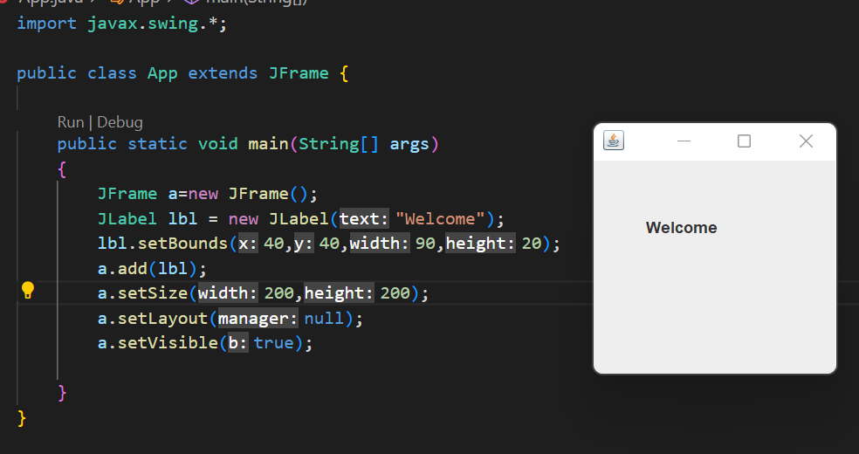
Example:

Code:
import javax.swing.*;

public class App extends JFrame {

public static void main(String[] args)
{
JFrame a=new JFrame();
JLabel lbl = new JLabel("Welcome");
lbl.setBounds(40,40,90,20);
a.add(lbl);
a.setSize(200,200);
a.setLayout(null);
a.setVisible(true);

}
}

JRadioButton
This component allows the user to select only one item from a group item. By using the JRadioButton component you can choose one option from multiple options.
Syntax: JRadioButton jrb = new JRadioButton();

JRadioButton Constructors
- JRadioButton(): It is used to create an unselected radio button with no text.
- JRadioButton(Label): It is used to create an unselected radio button with specified text.
- JRadioButton(Label, boolean): It is used to create a radio button with the specified text and selected status.
Code:

import javax.swing.*;
public class App {
public static void main(String[] args)
{
JFrame f=new JFrame();
JRadioButton r1=new JRadioButton("A) Male",true);
JRadioButton r2=new JRadioButton("B) Female");
r1.setBounds(75,50,100,30);
r2.setBounds(75,100,100,30);
ButtonGroup bg=new ButtonGroup();
bg.add(r1);
bg.add(r2);
f.add(r1);
f.add(r2);
f.setSize(300,300);
f.setLayout(null);
f.setVisible(true);

}
}

Output:
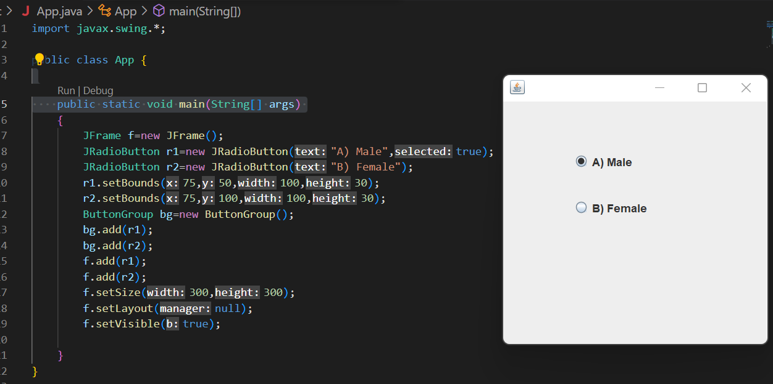
JPasswordField
The object of a JPasswordField class is a text component specialized for password entry. It allows the editing of a single line of text. It inherits JTextField class.

Constructor | Description
JPasswordField() | Constructs a new JPasswordField, with a default document, null starting text string, and 0 column width.
JPasswordField(int columns) | Constructs a new empty JPasswordField with the specified number of columns.
JPasswordField(String text) | Constructs a new JPasswordField initialized with the specified text.
JPasswordField(String text, int columns) | Construct a new JPasswordField initialized with the specified text and columns.

Code:
import javax.swing.*;

public class App {

public static void main(String[] args)
{
JFrame f=new JFrame();

JPasswordField value = new JPasswordField();
JLabel l1=new JLabel("Password:");
l1.setBounds(20,100, 80,30);
value.setBounds(100,100,100,30);
f.add(value); f.add(l1);
f.setSize(300,300);
f.setLayout(null);
f.setVisible(true);

}
}
Output:
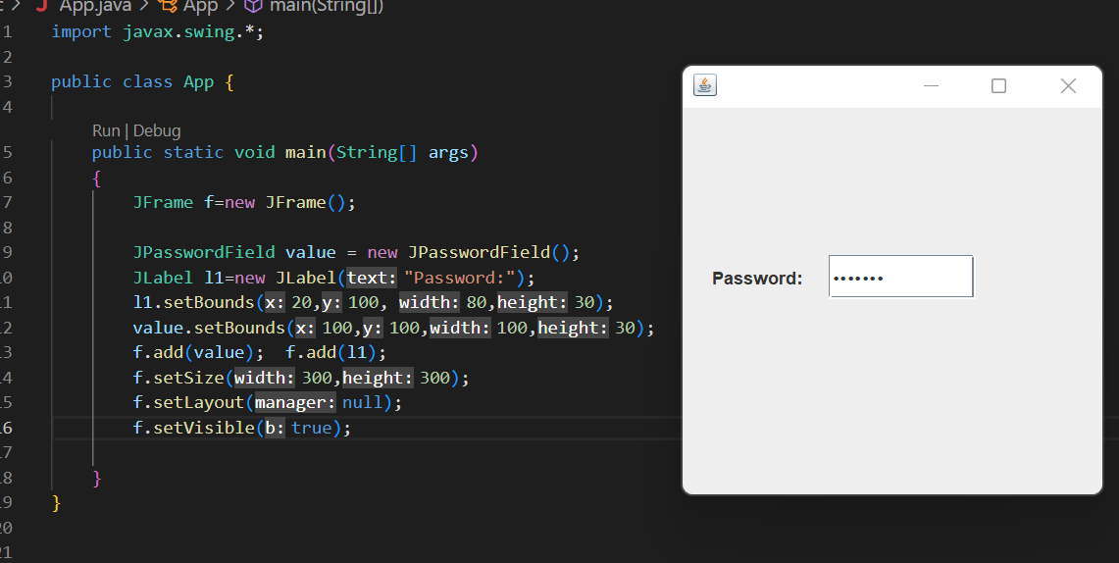
JCheckBox
The JCheckBox class is used to create a checkbox. It is used to turn an option on (true) or off (false). Clicking on a CheckBox changes its state from "on" to "off" or from "off" to "on ".It inherits JToggleButton class.
Constructor | Description
JJCheckBox() | Creates an initially unselected check box button with no text, no icon.
JChechBox(String s) | Creates an initially unselected check box with text.
JCheckBox(String text, boolean selected) | Creates a check box with text and specifies whether or not it is initially selected.
JCheckBox(Action a) | Creates a check box where properties are taken from the Action supplied.

Code:
import javax.swing.*;

public class App {

public static void main(String[] args)
{
JFrame f=new JFrame();

JCheckBox checkBox1 = new JCheckBox("C++");
checkBox1.setBounds(100,100, 50,50);
JCheckBox checkBox2 = new JCheckBox("Java", true);
checkBox2.setBounds(100,150, 100,50);
f.add(checkBox1);
f.add(checkBox2);
f.setSize(200,200);
f.setLayout(null);
f.setVisible(true);

}
}
Output:
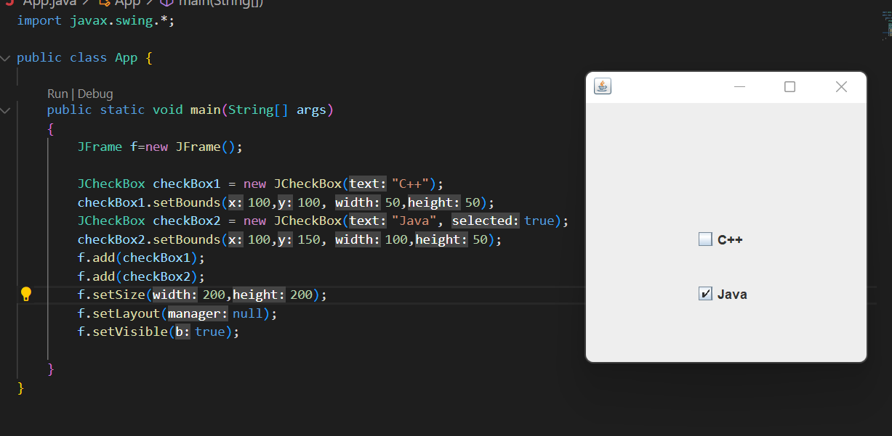

JComboBox
It inherits the JComponent class and is used to show pop up menu of choices.

import javax.swing.*;

public class App {

public static void main(String[] args)
{
JFrame f=new JFrame();
String courses[] = { "core java","advance java", "java servlet"};
JComboBox c = new JComboBox(courses);
c.setBounds(40,40,90,20);
f.add(c);
f.setSize(400,400);
f.setLayout(null);
f.setVisible(true);

}
}
Output:
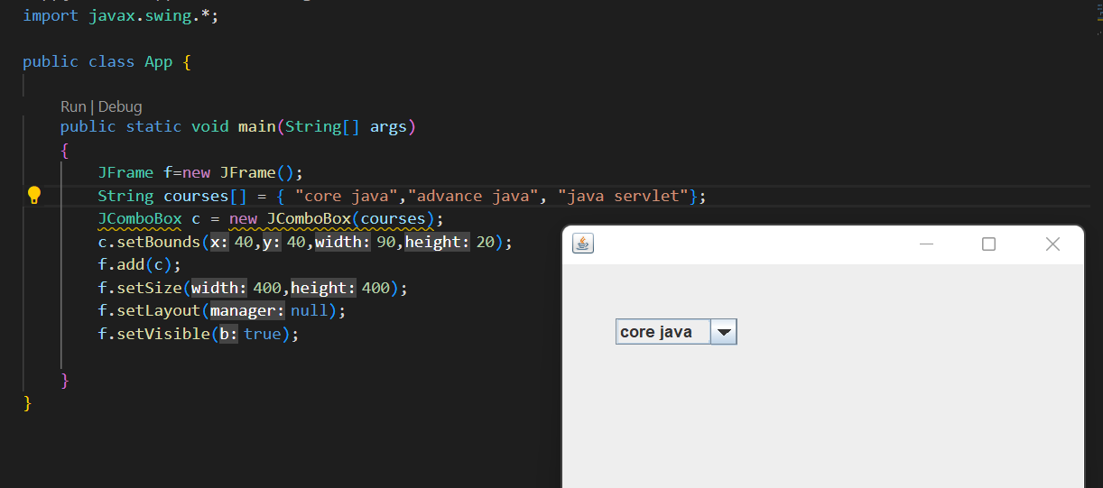
JTextArea
The object of a JTextArea class is a multi line region that displays text. It allows the editing of multiple line text. It inherits JTextComponent class

Commonly used Constructors:

Constructor | Description
JTextArea() | Creates a text area that displays no text initially.
JTextArea(String s) | Creates a text area that displays specified text initially.
JTextArea(int row, int column) | Creates a text area with the specified number of rows and columns that displays no text initially.
JTextArea(String s, int row, int column) | Creates a text area with the specified number of rows and columns that displays specified text.

Code:
import javax.swing.*;

public class App {

public static void main(String[] args)
{
JFrame f=new JFrame();
JTextArea area=new JTextArea("Welcome to Swastik");
area.setBounds(10,30, 200,200);
f.add(area);
f.setSize(300,300);
f.setLayout(null);
f.setVisible(true);

}
}

Output
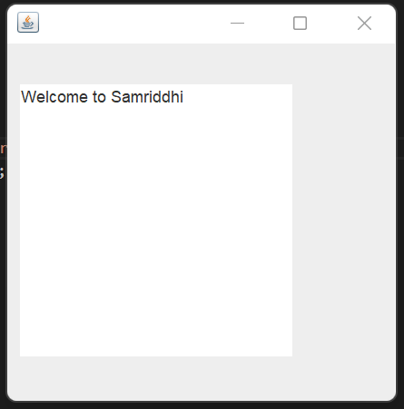

JScrollPane
A JscrollPane is used to make scrollable view of a component. When screen size is limited, we use a scroll pane to display a large component or a component whose size can change dynamically.
Commonly Used Method
Constructor | Purpose
JScrollPane() | It creates a scroll pane. The Component parameter, when present, sets the scroll pane's client. The two int parameters, when present, set the vertical and horizontal scroll bar policies (respectively).
JScrollPane(Component)
JScrollPane(int, int)
JScrollPane(Component, int, int)

Code:
import javax.swing.*;
import java.awt.FlowLayout;

public class App {
App()
{
JFrame f=new JFrame();
// Display the window.
f.setSize(500, 500);
f.setVisible(true);
f.setDefaultCloseOperation(JFrame.EXIT_ON_CLOSE);

// set flow layout for the frame
f.getContentPane().setLayout(new FlowLayout());

JTextArea textArea = new JTextArea(20, 20);

JScrollPane scrollableTextArea = new JScrollPane(textArea);

scrollableTextArea.setHorizontalScrollBarPolicy(JScrollPane.HORIZONTAL_SCROLLBAR_ALWAYS);
scrollableTextArea.setVerticalScrollBarPolicy(JScrollPane.VERTICAL_SCROLLBAR_ALWAYS);

f.getContentPane().add(scrollableTextArea);
}

public static void main(String[] args)
{

javax.swing.SwingUtilities.invokeLater(new Runnable() {

public void run() {
new App();
}
});
}

Output:
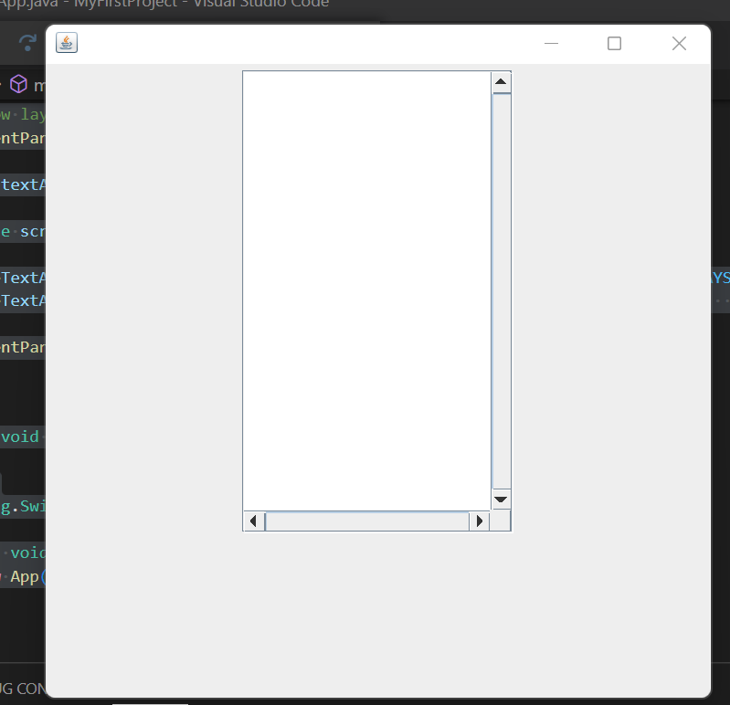
Border Swing Control in Java
The border is an interface using which we can apply a border to every component. To create the borders we have to use the methods available in BorderFactory class. We can apply the created border to any component by using the SetBorder() method.
Syntax: Component.setBorder(Border);
Methods of Border
- Border createLineBorder(Color, int): It is used to create a line border. Here, the Color object specifies the color of the line and int specifies the width in pixels of the line.
- Border createEtchedBorder(int, Color, Color): It is used to create an etched border. Here, Color arguments specify the highlight and shadow colors to be used. Here, int arguments allow the border methods to be specified as either EtchedBorder.RAISED or EtchedBorder.LOWERED. The methods without the int arguments create a lowered etched border.
- Border createBevelBorder(int, Color, Color): It is used to create a raised or lowered beveled border, specifying the colors to use. Here, the integer argument can be either BevelBorder.RAISED or BevelBorder.LOWERED. Here, Color specifies the highlight and shadow colors.
- MatteBorder createMatteBorder(int, int, int, int, Icon): It is used to create a matte border. Here, the integer arguments specify the number of pixels that the border occupies at the top, left, bottom, and right (in that order) of whatever component uses it. Here, the color argument specifies the color which with the border should fill its area. Here, the icon argument specifies the icon which with the border should tile its area.
- TitledBorder createTitledBorder(Border, String, int, int, Font, Color): Create a titled border. Here, the string argument specifies the title to be displayed. Here, the optional font and color arguments specify the font and color to be used for the title’s text. Here, the border argument specifies the border that should be displayed along with the title. Here, the integer arguments specify the number of pixels that the border occupies at the top, left, bottom, and right (in that order) of whatever component uses it.
- CompoundBorder createCompoundBorder(Border, Border): Combine two borders into one. Here, the first argument specifies the outer border; the second, the inner border.

Code:
import javax.swing.*;

public class App {

public static void main(String[] args)
{
JFrame f=new JFrame();
JPanel j=new JPanel();
JTextArea area=new JTextArea("Welcome to Samriddhi");
area.setBorder(BorderFactory.createTitledBorder("Group Box"));
area.setBounds(10,30, 200,200);
f.add(j);
f.add(area);
f.setSize(300,300);
f.setLayout(null);
f.setVisible(true);

}
}

Output:
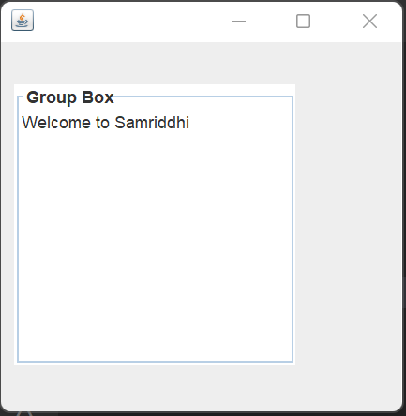

Menu, Menu Item:
Code:
import javax.swing.*;

public class App {

public static void main(String[] args)
{
JMenu menu, submenu;
JMenuItem i1, i2, i3, i4, i5;

JFrame f= new JFrame("Menu and MenuItem Example");
JMenuBar mb=new JMenuBar();
menu=new JMenu("Menu");
submenu=new JMenu("Sub Menu");
i1=new JMenuItem("Item 1");
i2=new JMenuItem("Item 2");
i3=new JMenuItem("Item 3");
i4=new JMenuItem("Item 4");
i5=new JMenuItem("Item 5");
menu.add(i1);
menu.add(i2);
menu.add(i3);
submenu.add(i4);
submenu.add(i5);
menu.add(submenu);
mb.add(menu);
f.setJMenuBar(mb);
f.setSize(400,400);
f.setLayout(null);
f.setVisible(true);

}
}

Output:
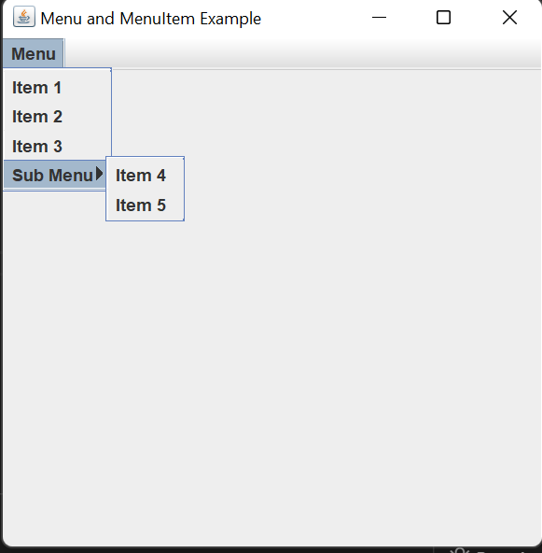
Jpopup Menu
Code:
import javax.swing.*;
import java.awt.event.*;

public class App {

public static void main(String[] args)
{
JFrame f= new JFrame("PopupMenu Example");
JPopupMenu popupmenu = new JPopupMenu("Edit");
JMenuItem cut = new JMenuItem("Cut");
JMenuItem copy = new JMenuItem("Copy");
JMenuItem paste = new JMenuItem("Paste");
popupmenu.add(cut);
popupmenu.add(copy);
popupmenu.add(paste);

f.addMouseListener(new MouseAdapter() {
public void mouseClicked(MouseEvent e) {
popupmenu.show(f , e.getX(), e.getY());
}
});

f.add(popupmenu);
f.setSize(300,300);
f.setLayout(null);
f.setVisible(true);

}
}

Output:
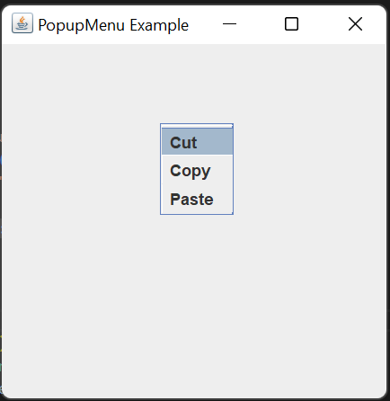
Adding Icon in Menu:

import javax.swing.*;
public class App {

public static void main(String[] args) {

JFrame f=new JFrame("Menu Icon Example");
ImageIcon img=new ImageIcon("new.png");
ImageIcon img2=new ImageIcon("Login.png");
ImageIcon img3=new ImageIcon("Logout.png");
ImageIcon img4=new ImageIcon("Exit.png");
JMenu menu;
JMenuItem i1, i2, i3, i4;

JMenuBar mb=new JMenuBar();
menu=new JMenu("Menu");

i1=new JMenuItem("New",img);
i2=new JMenuItem("Login",img2);
i3=new JMenuItem("Logout",img3);
i4=new JMenuItem("Exit",img4);

menu.add(i1);
menu.add(i2);
menu.add(i3);
menu.add(i4);

mb.add(menu);
f.setJMenuBar(mb);
f.setSize(400,400);
f.setLayout(null);
f.setVisible(true);

}
}

Output:
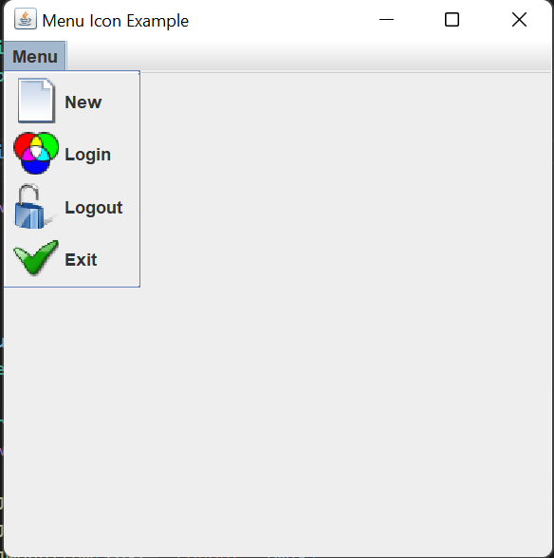
Disable Menu Item
i1.setEnabled(false);
Code:
import javax.swing.*;
public class App {

public static void main(String[] args) {

JFrame f=new JFrame("Menu Icon Example");
ImageIcon img=new ImageIcon("new.png");
ImageIcon img2=new ImageIcon("Login.png");
ImageIcon img3=new ImageIcon("Logout.png");
ImageIcon img4=new ImageIcon("Exit.png");
JMenu menu;
JMenuItem i1, i2, i3, i4;

JMenuBar mb=new JMenuBar();
menu=new JMenu("Menu");

i1=new JMenuItem("New",img);
i2=new JMenuItem("Login",img2);
i3=new JMenuItem("Logout",img3);
i4=new JMenuItem("Exit",img4);

menu.add(i1);
menu.add(i2);
menu.add(i3);
menu.add(i4);
i1.setEnabled(false);

mb.add(menu);
f.setJMenuBar(mb);
f.setSize(400,400);
f.setLayout(null);
f.setVisible(true);

}
}

Adding Tooltip:
i1.setToolTipText("It Creates New");
Code:
import javax.swing.*;
public class App {

public static void main(String[] args) {

JFrame f=new JFrame("Menu Icon Example");
ImageIcon img=new ImageIcon("new.png");
ImageIcon img2=new ImageIcon("Login.png");
ImageIcon img3=new ImageIcon("Logout.png");
ImageIcon img4=new ImageIcon("Exit.png");
JMenu menu;
JMenuItem i1, i2, i3, i4;

JMenuBar mb=new JMenuBar();
menu=new JMenu("Menu");

i1=new JMenuItem("New",img);
i2=new JMenuItem("Login",img2);
i3=new JMenuItem("Logout",img3);
i4=new JMenuItem("Exit",img4);

menu.add(i1);
menu.add(i2);
menu.add(i3);
menu.add(i4);
i1.setToolTipText("It Creates New");

mb.add(menu);
f.setJMenuBar(mb);
f.setSize(400,400);
f.setLayout(null);
f.setVisible(true);

}
}

Output:
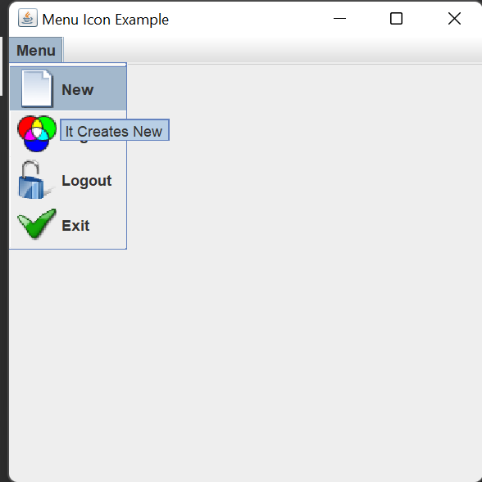

Toolbar :
import javax.swing.*;
import java.awt.*;
public class App {

public static void main(String[] args) {

JFrame f=new JFrame("Menu Icon Example");
ImageIcon img1=new ImageIcon("new.png");
ImageIcon img2=new ImageIcon("Login.png");
ImageIcon img3=new ImageIcon("Logout.png");

JToolBar toolbar = new JToolBar();
// create a panel
JPanel p = new JPanel();

JButton newBtn = new JButton(img1);
JButton openBtn = new JButton(img2);
JButton saveBtn = new JButton(img3);

toolbar.add(newBtn);
toolbar.add(openBtn);
toolbar.add(saveBtn);

// add panel to toolbar

toolbar.add(p);
// add toolbar to frame
f.add(toolbar, BorderLayout.NORTH);

// set the size of the frame
f.setSize(500, 500);
f.setVisible(true);

}
}

Output:
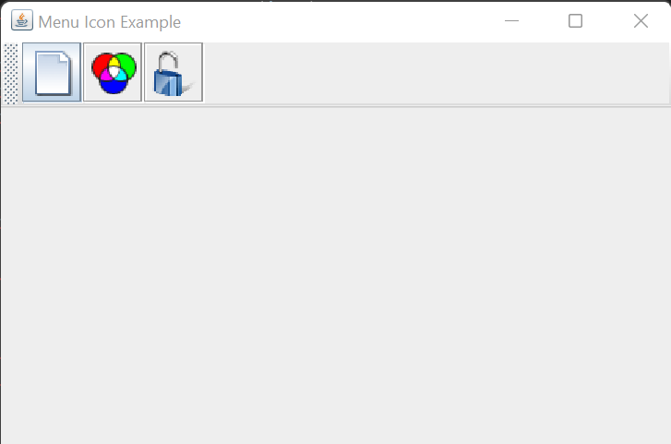
Keyboard Mnemonics and Accelerators:
Keyboard Mnemonics:
A menu mnemonic is a single-letter abbreviation for a menu command. When the menu has already been pulled down, the user can type this single key to invoke that menu item. The mnemonic for a menu item is typically indicated by underlining the letter of the shortcut in the menu item name, which means that you must select a shortcut letter that appears in the menu item label. Mnemonics must be unique within a menu, of course, but multiple menu panes can reuse mnemonics. Items in a menu bar may also have mnemonics. You specify a mnemonic for a menu or a menu item with the setMnemonic() method.
Example:
import javax.swing.*;

public class App {
public static void main(String[] args) {

JMenu menu, submenu;
JMenuItem i1, i2, i3, i4, i5;

JFrame f= new JFrame("Menu and MenuItem Example");
JMenuBar mb=new JMenuBar();
menu=new JMenu("Menu");
menu.setMnemonic('M');
submenu=new JMenu("Sub Menu");
i1=new JMenuItem("Item 1");
i2=new JMenuItem("Item 2");
i3=new JMenuItem("Item 3");
i4=new JMenuItem("Item 4");
i5=new JMenuItem("Item 5");
menu.add(i1);
menu.add(i2);
menu.add(i3);
submenu.add(i4);
submenu.add(i5);
menu.add(submenu);
mb.add(menu);
f.setJMenuBar(mb);
f.setSize(400,400);
f.setLayout(null);
f.setVisible(true);

}
}
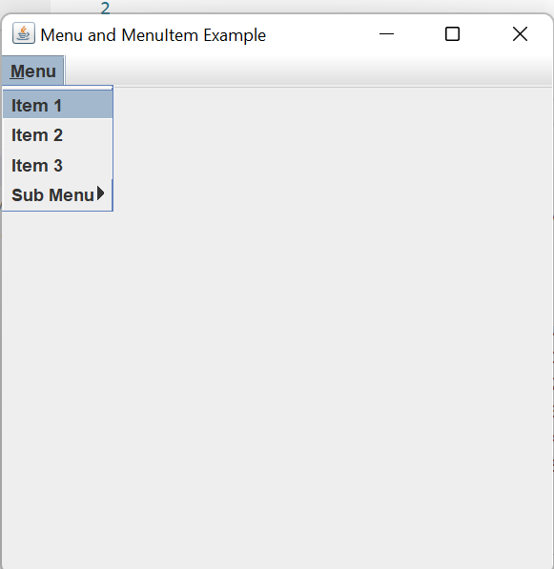

Layout Management:
The LayoutManagers are used to arrange components in a particular manner. The Java LayoutManagers facilitates us to control the positioning and size of the components in GUI forms. LayoutManager is an interface that is implemented by all the classes of layout managers. There are the following classes that represent the layout managers:
The Abstract Windowing Toolkit (AWT) has the following five layout managers:
- java.awt.BorderLayout
- java.awt.FlowLayout
- java.awt.GridLayout
- java.awt.CardLayout
- java.awt.GridBagLayout
Some of these are used in the swing:
- javax.swing.BoxLayout
- javax.swing.ScrollPanelLayout
- javax.swing.GroupLayout
- javax.swing.SpringLayout
No Layout:
import javax.swing.*;
public class App extends JFrame{
JFrame f;
App()
{
JButton b=new JButton("click");//create button
b.setBounds(130,100,100, 40);

add(b);//adding button on frame
setSize(400,500);
setLayout(null);
setVisible(true);
}

public static void main(String[] args)
{
App app=new App();
}

}

Flow Layout:
The Java FlowLayout class is used to arrange the components in a line, one after another (in a flow). It is the default layout of the panel.
Fields of FlowLayout class
- public static final int LEFT(3)
- public static final int RIGHT(2)
- public static final int CENTER(1)
- public static final int LEADING
- public static final int TRAILING
Example:
import javax.swing.*;
import java.awt.*;
public class App{
JFrame f;
App()
{
f=new JFrame();
// creating the buttons
JButton b1 = new JButton("1");
JButton b2 = new JButton("2");
JButton b3 = new JButton("3");
JButton b4 = new JButton("4");
JButton b5 = new JButton("5");
JButton b6 = new JButton("6");
JButton b7 = new JButton("7");
JButton b8 = new JButton("8");
JButton b9 = new JButton("9");
JButton b10 = new JButton("10");
f.add(b1); f.add(b2); f.add(b3); f.add(b4);
f.add(b5); f.add(b6); f.add(b7); f.add(b8);
f.add(b9); f.add(b10);

// parameter less constructor is used
// therefore, alignment is center
// horizontal as well as the vertical gap is 5 units.
f.setLayout(new FlowLayout());

f.setSize(300, 300);
f.setVisible(true);
}

public static void main(String[] args)
{
App app=new App();
}

}

Output:
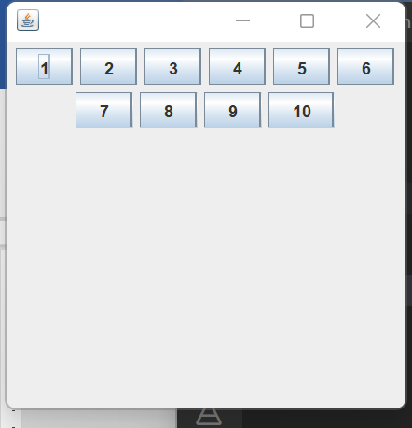

Java BorderLayout
The BorderLayout is used to arrange the components in five regions: north, south, east, west, and center. Each region (area) may contain one component only. It is the default layout of a frame or window. The BorderLayout provides five constants for each region:
- public static final int NORTH
- public static final int SOUTH
- public static final int EAST
- public static final int WEST
- public static final int CENTER
Constructors of BorderLayout class:
- BorderLayout(): creates a border layout but with no gaps between the components.
- BorderLayout(int hgap, int vgap): creates a border layout with the given horizontal and vertical gaps between the components.

Example:
import javax.swing.*;
import java.awt.*;
public class App{
JFrame f;
App()
{

f=new JFrame();
// creating buttons
JButton b1 = new JButton("NORTH");; // the button will be labeled as NORTH
JButton b2 = new JButton("SOUTH");; // the button will be labeled as SOUTH
JButton b3 = new JButton("EAST");; // the button will be labeled as EAST
JButton b4 = new JButton("WEST");; // the button will be labeled as WEST
JButton b5 = new JButton("CENTER");; // the button will be labeled as CENTER

f.add(b1, BorderLayout.NORTH); // b1 will be placed in the North Direction
f.add(b2, BorderLayout.SOUTH); // b2 will be placed in the South Direction
f.add(b3, BorderLayout.EAST); // b2 will be placed in the East Direction
f.add(b4, BorderLayout.WEST); // b2 will be placed in the West Direction
f.add(b5, BorderLayout.CENTER); // b2 will be placed in the Center

f.setSize(300, 300);
f.setVisible(true);
}

public static void main(String[] args)
{
App app=new App();
}

}

Output:
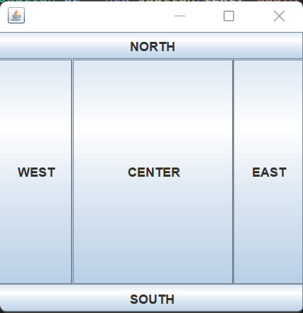

Grid Layout:
The Java GridLayout class is used to arrange the components in a rectangular grid. One component is displayed in each rectangle.
Constructors of GridLayout class
- GridLayout(): creates a grid layout with one column per component in a row.
- GridLayout(int rows, int columns): creates a grid layout with the given rows and columns but no gaps between the components.
- GridLayout(int rows, int columns, int hgap, int vgap): creates a grid layout with the given rows and columns along with given horizontal and vertical gaps.
Example:
import javax.swing.*;
import java.awt.*;
public class App{
JFrame f;
App()
{

f=new JFrame();

// creating 9 buttons
JButton btn1 = new JButton("1");
JButton btn2 = new JButton("2");
JButton btn3 = new JButton("3");
JButton btn4 = new JButton("4");
JButton btn5 = new JButton("5");
JButton btn6 = new JButton("6");
JButton btn7 = new JButton("7");
JButton btn8 = new JButton("8");
JButton btn9 = new JButton("9");
f.add(btn1); f.add(btn2); f.add(btn3);
f.add(btn4); f.add(btn5); f.add(btn6);
f.add(btn7); f.add(btn8); f.add(btn9);
// setting the grid layout using the parameterless constructor
f.setLayout(new GridLayout());

f.setSize(300, 300);
f.setVisible(true);
}

public static void main(String[] args)
{
App app=new App();
}

}

Output:
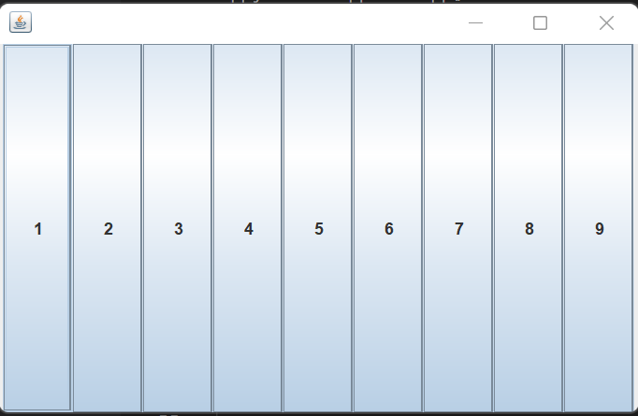
GridBagLayout:
class is used to align components vertically, horizontally or along their baseline.
The components may not be of the same size. Each GridBagLayout object maintains a dynamic, rectangular grid of cells. Each component occupies one or more cells known as its display area.

Example:
import java.awt.Button;
import java.awt.GridBagConstraints;
import java.awt.GridBagLayout;
import javax.swing.*;
public class App extends JFrame{
App()
{
GridBagLayout grid = new GridBagLayout();
GridBagConstraints gbc = new GridBagConstraints();
setLayout(grid);
setTitle("GridBag Layout Example");
GridBagLayout layout = new GridBagLayout();
this.setLayout(layout);
gbc.fill = GridBagConstraints.HORIZONTAL;
gbc.gridx = 0;
gbc.gridy = 0;
this.add(new Button("Button One"), gbc);
gbc.gridx = 1;
gbc.gridy = 0;
this.add(new Button("Button two"), gbc);
gbc.fill = GridBagConstraints.HORIZONTAL;
gbc.ipady = 20;
gbc.gridx = 0;
gbc.gridy = 1;
this.add(new Button("Button Three"), gbc);
gbc.gridx = 1;
gbc.gridy = 1;
this.add(new Button("Button Four"), gbc);
gbc.gridx = 0;
gbc.gridy = 2;
gbc.fill = GridBagConstraints.HORIZONTAL;
gbc.gridwidth = 2;
this.add(new Button("Button Five"), gbc);
setSize(300, 300);
setPreferredSize(getSize());
setVisible(true);
setDefaultCloseOperation(EXIT_ON_CLOSE);

}

public static void main(String[] args)
{
App ap=new App();
}

}

Output:
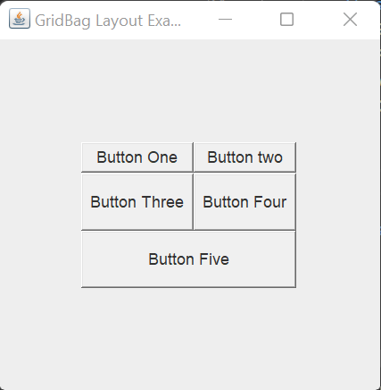

GroupLayout
GroupLayout groups its components and places them in a Container hierarchically. The grouping is done by instances of the Group class.
Example:
import java.awt.*;

import javax.swing.*;
public class App extends JFrame{

public static void main(String[] args)
{
JFrame frame = new JFrame("GroupLayoutExample");
frame.setDefaultCloseOperation(JFrame.EXIT_ON_CLOSE);
Container contentPanel = frame.getContentPane();
GroupLayout groupLayout = new GroupLayout(contentPanel);

contentPanel.setLayout(groupLayout);

JLabel clickMe = new JLabel("Click Here");
JButton button = new JButton("This Button");

groupLayout.setHorizontalGroup(
groupLayout.createSequentialGroup()
.addComponent(clickMe)
.addGap(10, 20, 100)
.addComponent(button));
groupLayout.setVerticalGroup(
groupLayout.createParallelGroup(GroupLayout.Alignment.BASELINE)
.addComponent(clickMe)
.addComponent(button));
frame.pack();
frame.setVisible(true);
}

}

Output:
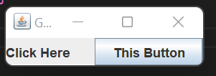

Working with 2D Shapes:
Lab: Write a java program to draw a line in Frame.
Draw Line:
import javax.swing.*;
import java.awt.*;
public class App extends Canvas {
//draw the shapes
@Override
public void paint (Graphics graphics){
graphics.setColor(Color.BLACK);
graphics.drawLine(100, 100, 340, 380);
}
public static void main(String[] args) throws Exception {
// Sets up the drawing canvas
App canvas = new App();
JFrame f=new JFrame();
f.getContentPane().add(canvas);
f.setSize(400,500);
f.setVisible(true);
f.setDefaultCloseOperation(JFrame.EXIT_ON_CLOSE);

}
}

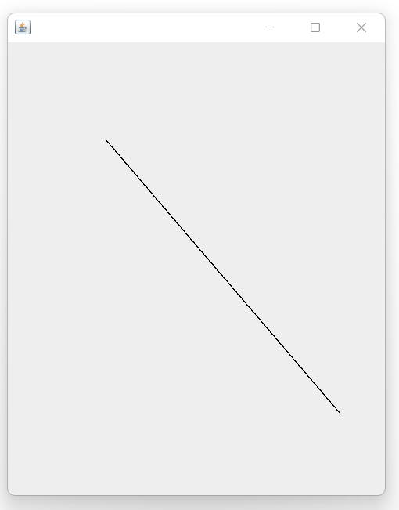
Draw Rectangle of size 100x100
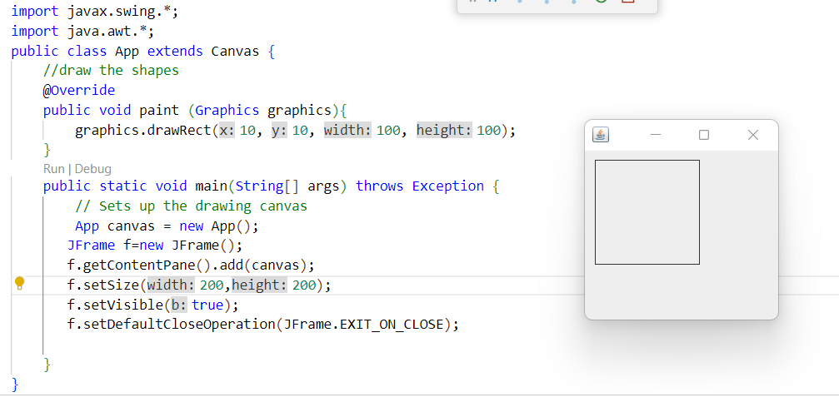

Draw Rectangle with border red:
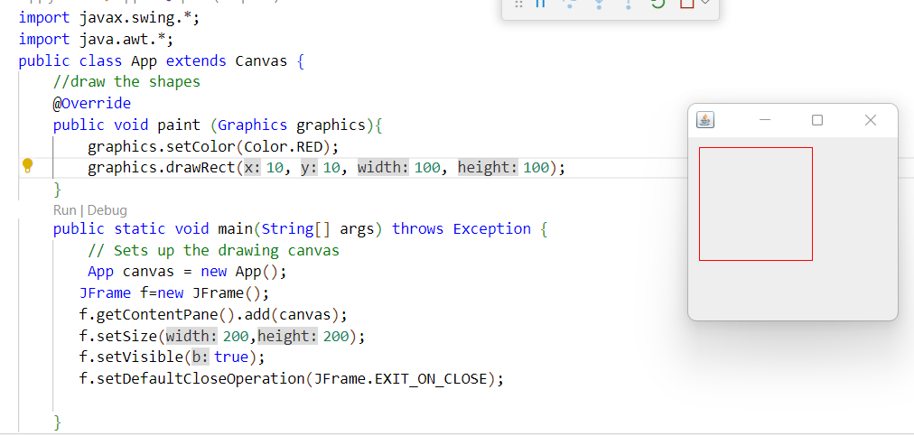
Draw a fill rectangle:
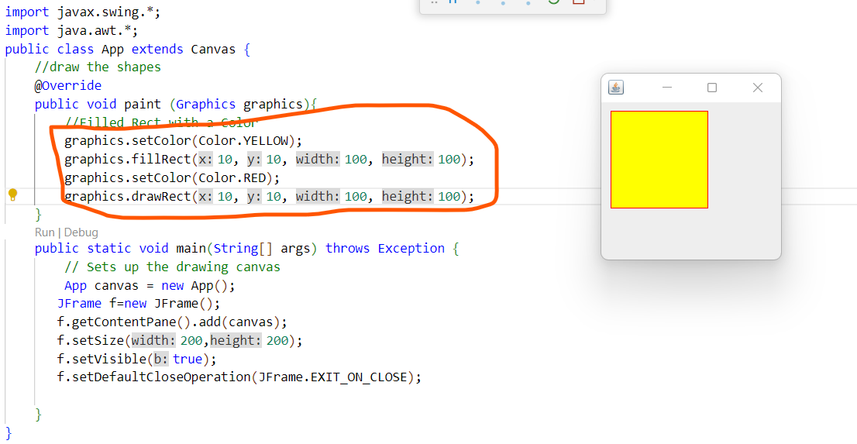

Write a program to draw 2D circle with line color red and fill with color yellow.
Draw a Circle:
